THE RIGHT PEOPLE. THE RIGHT SERVICE.

**BACK OF CARD**

Name

Job Title



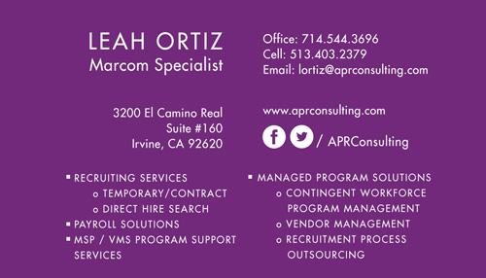

/ APRConsulting

www.website.com

Office: 555.555.5555

Cell: 555.555.5555

Email: email@email.com

Address:

1234 Street View Drive

Suite 111

City Name, ST 12345